PRESS RELEASE

Smart Evaporator Assists Medicinal Chemistry
BioChromato Inc. has published an interview with the Department of Medicinal Chemistry and Molecular Pharmacology at Purdue University (Indiana, USA) that explains how the Smart Evaporator C1 has assisted them in isolating and purifying novel compounds from DMSO solutions for potential pharmaceutical use.
Because the US Federal Drug Administration (FDA) does not approve DMSO formulations for human administration, researchers at Purdue University wanted to synthesise a new Platinum (IV) chloride complex: Na [PtCl5 (DMSO)] in aqueous DMSO and then isolate the final product as a dry powder.
However, as the Platinum (IV) chloride complex was water soluble it was impossible to isolate it, free of DMSO solvent, using conventional organic solvent extraction methods. Also completely removing DMSO solvent using lyophilization techniques was found to be both time consuming and gave inconsistent results.
Dr V Jo Davisson, Professor of Medicinal Chemistry and Molecular Pharmacology at Purdue University said " The SMART Evaporator C1 from BioChromato has enabled us to

quickly and reproducibly produce our Platinum (IV) chloride complex as a dry powder free of any unbound DMSO solvent in a range of different vessels. This new methodology shows great promise for producing compounds for pharmaceutical use from DMSO solutions".
Drawing upon BioChromato's patented Spiral Plug™ evaporation technology, the compact, benchtop Smart Evaporator C1 offers fast and effective evaporation in tubes or vials without solvent bumping thereby eliminating risk of sample loss, cross contamination and saving researchers time. The Smart Evaporator C1 is optimised to handle solvent volumes up to 40 mL which can be extremely useful for concentrating compounds after organic synthesis or drying analytical samples at relatively high speeds. The versatile C1 can also take small tubes and vials (e.g. 1.5mL) where solvent volumes can be as little as 0.1ml (or less).
To read the interview in full please visit https://biochromato.com/testimonials/smart-evaporator/special_interview/. For further information on the Smart Evaporator C1 please visit https://biochromato.com/smart-evaporator/ or contact BioChromato Inc. on +81-466-23-8382 / europe@bicr.co.jp / northamerica@bicr.co.jp and enquiries@bicr.co.jp.
Founded in 1983, BioChromato Inc is a respected Japanese manufacturer of unique high-quality products for chemical laboratories. Through its team of experienced technical experts and network of specialist distributors - BioChromato's aim is to enhance the efficiency of research and development through its development of problem-solving laboratory instruments and consumables.

DECEMBER 2020 Biochromatopr8.doc

Illustrative images: (available on request)
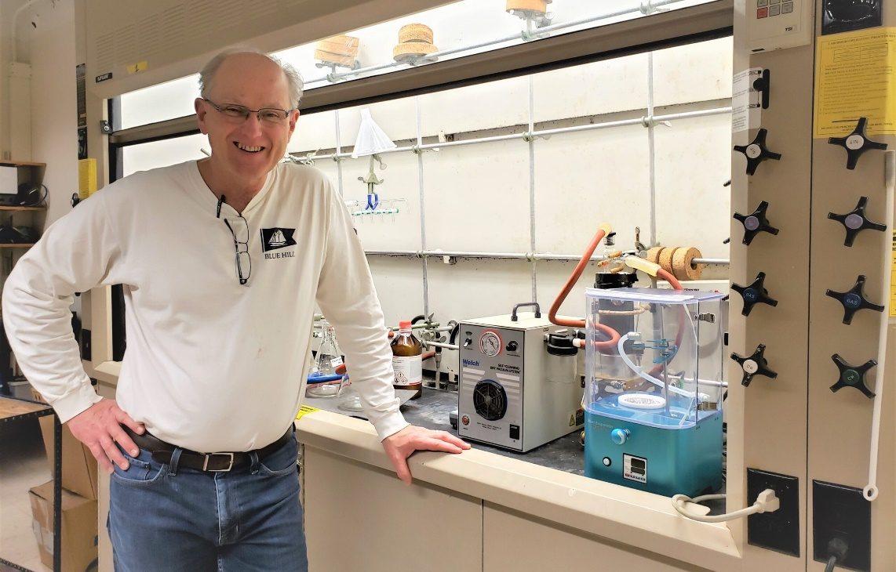
Caption: Professor Davisson with Smart Evaporator C1
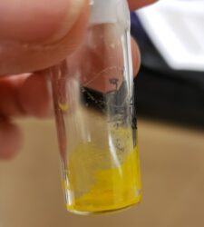
Caption: Compound dried in a vial

For more information please contact:
MEDIA: Dr Bill Bradbury +44-208-546-0869 / info@primetek-solutions.com

